Oqni: Finger motion classification

The purpose of this task is to classify finger motions based on readings from optical (infrared) sensors placed on the arm. There are a total of 16 sensor channels (2 sensors with 8 channels each). The data is labelled as followed:

* 0 - no finger motion
* 1, 2, 3, 4, 5 - motion of one of the five fingers

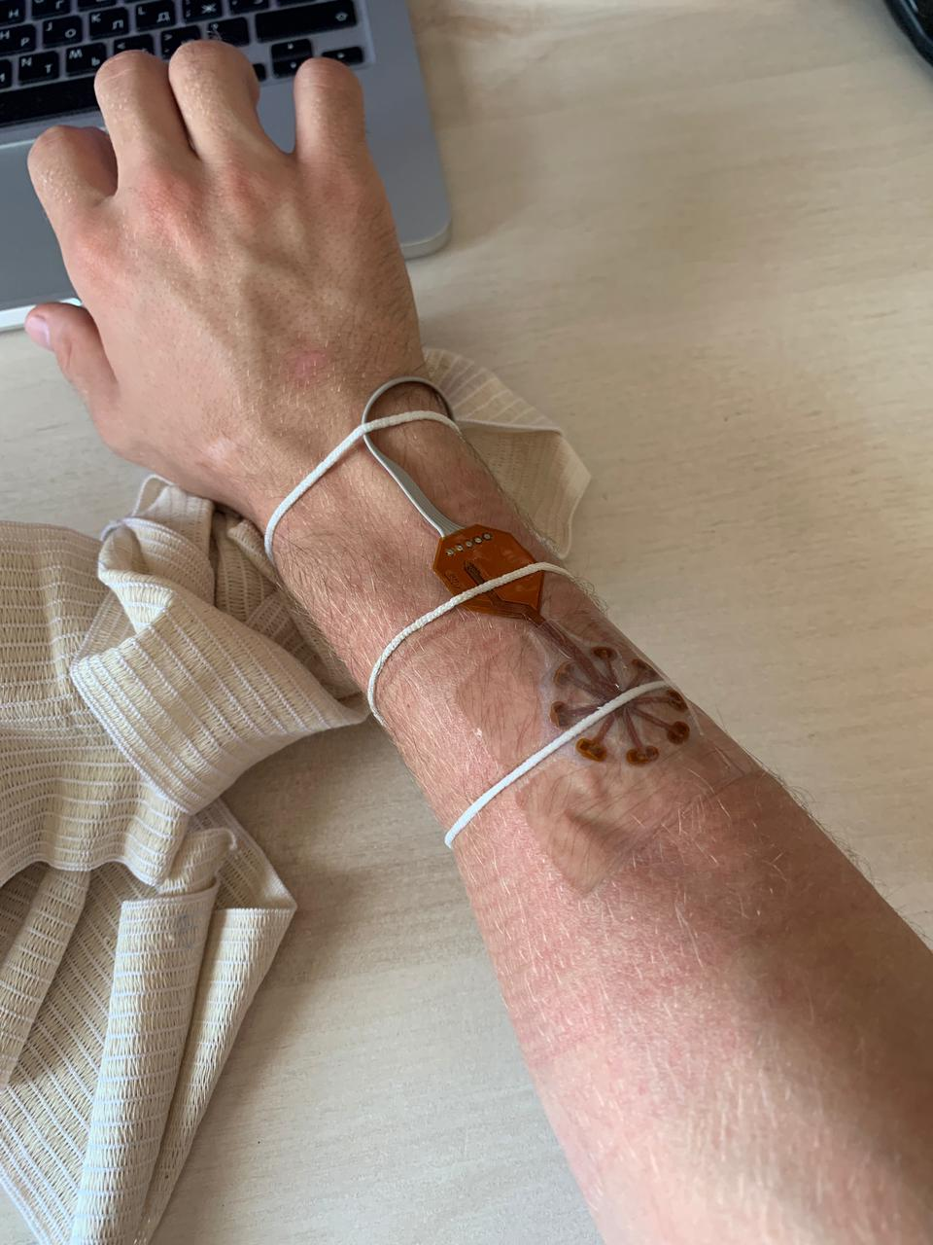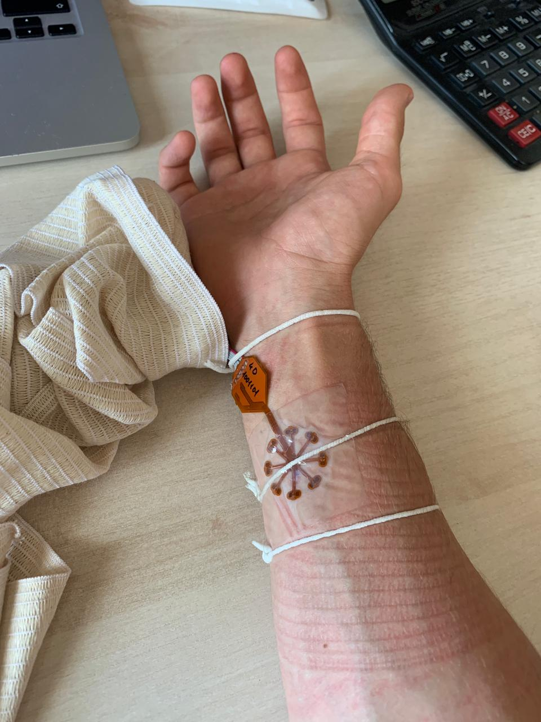

**Task:**

* Using the provided data, create an algorithm that will classify any new data from the same 16 channels into one of the 6 categories. The algorithm should achieve at least 70% f1-score for each of the individual classes, and a total accuracy of at least 90%. The scores will be calculated on test data (not provided).
* Submit a python script called finger_motion_classifier.py (alongside any necessary dependencies such as ML models) that can be run using the following command to produce labels for the set of test readings for a test_file.csv.

python finger_motion_classifier.py -f test_file.csv

The script should produce a file called predictions.txt which will have 1 row for every row in the test_file.txt with the corresponding label (a number from 0 to 5).

You can use any techniques that you find suitable, including fourier transforms, filtering, machine learning (including deep learning), etc. You can make up to 3 submissions by emailing all necessary files to run the script to [tsh.vahe@gmail.com](mailto:tsh.vahe@gmail.com). I will receive a reply with scores within 24 hours.